Lab 1: Introduction to Arduino

|  |  |
| --- | --- |
| to: | Chad McConnell |
| from: | Cory Wolfe and prehit patel |
| section: | MAE 311L - 06 |
| Lab date: | 17/01/2017 |
| Due Date: | 26/01/2017 |
|  |  |

1. SUMMARY

For this lab report the group performed a series of basic functions with an arduino, leds and a breadboard. The goal was to familiarize the group with basic arduino functions. This was done by writing and running a series of programs on the arduino. By doing this the group moved up from running the default blink program to lighting up an RGB LED a series of specific colors. The group attempted to follow the lab manual as closely as possible, however pin 11 on the groups arduino would not output a voltage. This was confirmed by only chaging the definition of a variable of a pin from 11 to 6. While outputing on the sixth pin the programs performed. Because of this the group did not use the eleventh pin when instructed and instead used another pin not in use.

1. results and analysis
2. Subsection 1

Organize the results section into subsections that describe each part of the lab. For example, if the first part of the lab tested thermocouples and the second part tested strain gauges, use two subsections to describe the results of each part separately. Present the results visually if possible (i.e. charts and graphs). Describe the results in paragraph form. Include a statement of any sources of error and/or error analysis. Make sure you can look at your results and understand what you did. Reference sources in text by numbering in order that they appear [1]. New information based off of second source [2]. You should have at least one reference (lab manual) in your report.

Discuss the results of the lab and include important figures and tables that support the conclusions. Sample calculations must be clearly shown using relevant equations. Any figures and tables included in the memo should be labeled according to the “Report Writing Guidelines and Layout” and discussed in the text. For example, see Table 1 and Figure 1 below for proper formatting of tables and figures.

1. Subsection 2

Show equations/sample calculations needed to support your answer. Equation 1 is an example of how to format equations with required sample calculation. Where fNyq is the calculated Nyquist frequency based upon the sample rate, fs, of the data acquisition system.

All questions in the lab manual should be answered. Do NOT just give yes/no/number answers to the questions. Explain what is occurring and include enough information in the answer to show understanding. If the answer came from an outside source, make sure to cite the source and include as a reference. Answer the questions section of the lab manual in a list format where the question is typed in italics and the answer is underneath.

Questions A:

1. *Question 1?*
   1. Answer
2. *Question 2?*
   1. Answer

References

1. Armentrout, D., “MAE 311L Lab 1: Introduction to Arduino,” Lab Manual, MAE Dept., Univ. Alabama in Huntsville, 2015.

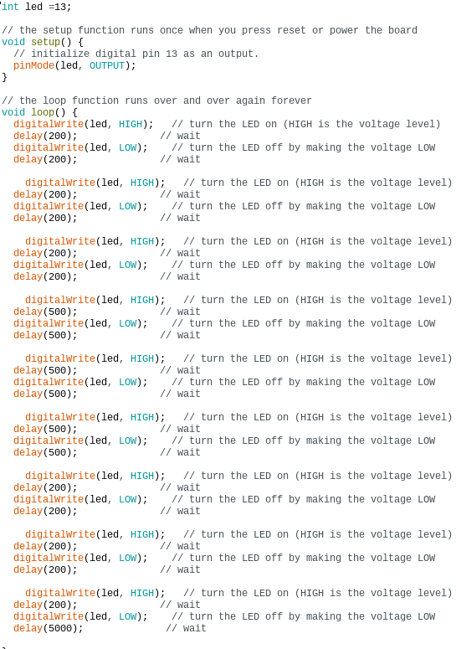  
**Figure** 1**: 3 Quick, 3 Slow, 3 Quick, 5 Second Wait Blinks Code**

**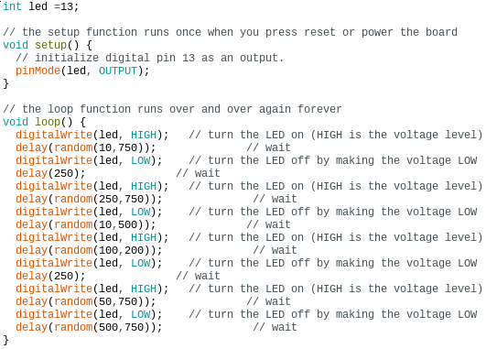  
Figure** 2**: Custom Four LED Blinks**

**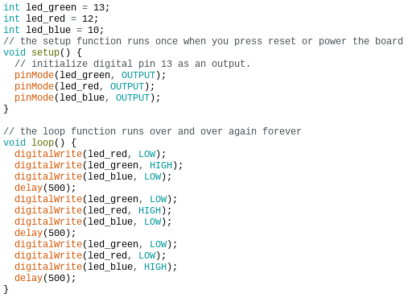  
Figure** 3**: Two Alternating LEDs**

 **Figure** 4**: Three Alternating LEDs**

**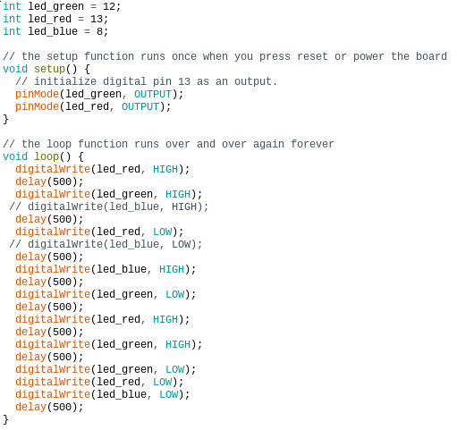  
Figure** 5**: RGB Color Mixing**